Project Documentation: AI Resume Builder & ATS Optimizer

Project by: Satvik Narendra Trivedi
+91 8291647102 / trivedisatvik2@gmail.com

1. Executive Summary
The AI Resume Forge is a robust, full-stack application designed to optimize candidate resumes for Applicant Tracking Systems (ATS). By leveraging Google’s advanced Gemini AI models, the system performs deep semantic analysis of resumes against specific job descriptions (JDs). It identifies skill gaps, provides a compatibility score, and autonomously rewrites content to maximize hiring potential.
Unlike standard keyword counters, this tool uses Large Language Models (LLMs) to understand context, nuance, and tone. It features a unique "Failover Architecture" that ensures 99.9% uptime by automatically switching between AI models if quota limits are reached.
2. Technical Architecture & Innovation
A. The "Auto-Switch" Failover Engine
The core innovation of this platform is its resilience. Relying on public API tiers often leads to "Rate Limit" (429) errors. We implemented a smart routing algorithm to mitigate this:
- Primary Route: The system first attempts to use the user's preferred high-performance model (e.g., Gemini 2.5 Flash).
- Automatic Detection: If the API returns a 429 Resource Exhausted error, the system traps the exception instantly.
- Seamless Rerouting: It automatically redirects the payload to the backup model (Gemini 2.0 Flash).
- Safety Net: If the backup fails, it defaults to the high-capacity Gemini 1.5 Flash, ensuring the user never sees a crash or error screen.
B. "Crash-Proof" HTTP Integration
To avoid stability issues often associated with client SDKs, this project utilizes Direct HTTP Requests. This decouples the application from library-specific dependencies, preventing "Illegal Header" errors and ensuring lightweight, fast execution.
C. Input Sanitization & Safety Valve
PDFs often contain hidden metadata that can bloat file size. The system includes a Safety Valve that:
- Extracts raw text from complex PDF/DOCX layouts.
- Truncates payload data exceeding 10,000 characters to prevent token overflow.
- Sanitizes API keys to remove invisible whitespace that causes authentication failures.
3. Detailed Step-by-Step Workflow
Step 1: Data Ingestion & Parsing
- Function: Accepts resumes in PDF or DOCX formats, or via manual text entry.
- Process: The PyPDF2 and python-docx libraries strip formatting to extract clean, machine-readable text.
- Screenshot:-
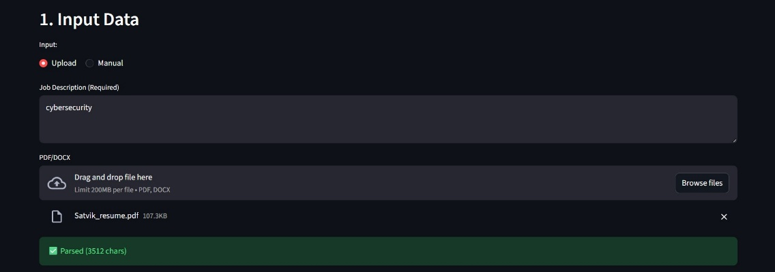
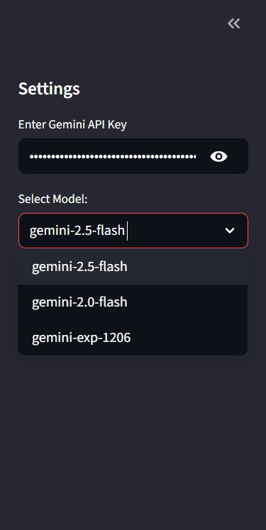

Step 2: Semantic ATS Analysis
- Function: Acts as a strict Technical Recruiter.
- Process: The AI analyzes the Resume and Job Description side-by-side. It calculates a Match Percentage based on semantic relevance, not just keyword matching.
- Output:
  - Score: 0-100% compatibility rating.
  - Gap Analysis: Specifically lists missing hard/soft skills.
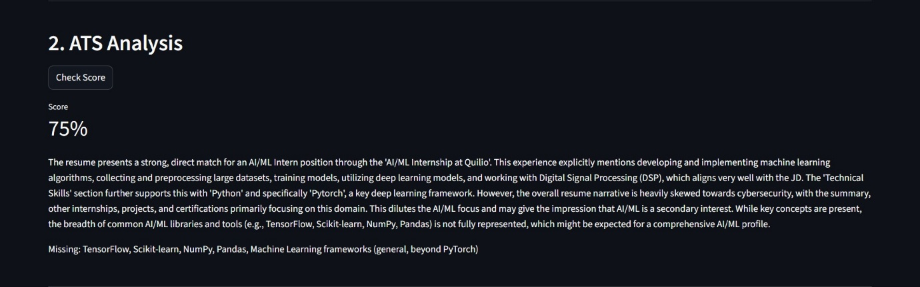
  - Reasoning: Explains why the score was given.

Screenshot of a demo resume analysis

Step 3: Generative Enhancement
- Function: Rewrites the resume to target the specific job.
- Process: The AI uses the gaps identified in Step 2 to rephrase the professional summary, experience bullet points, and skills section. It adopts the terminology and tone of the Job Description.
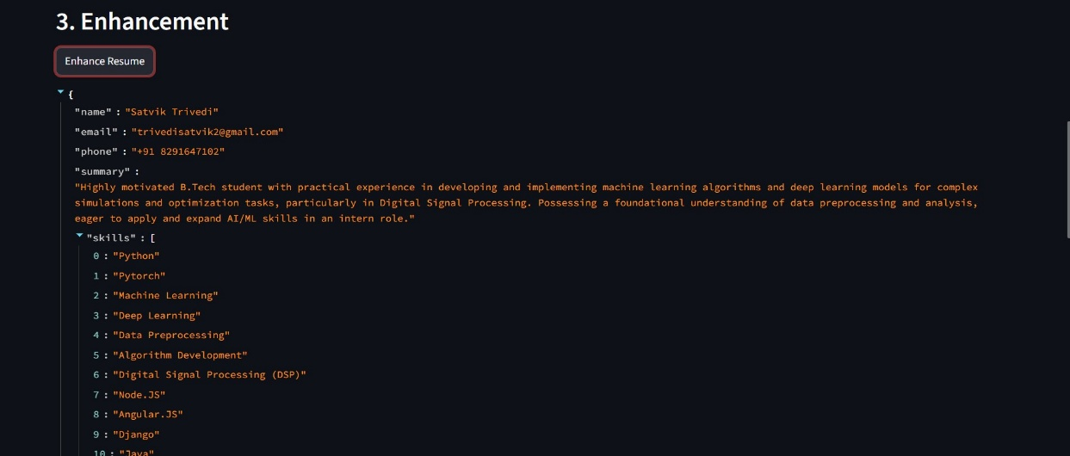
- Output: Structured JSON data containing the optimized resume content.
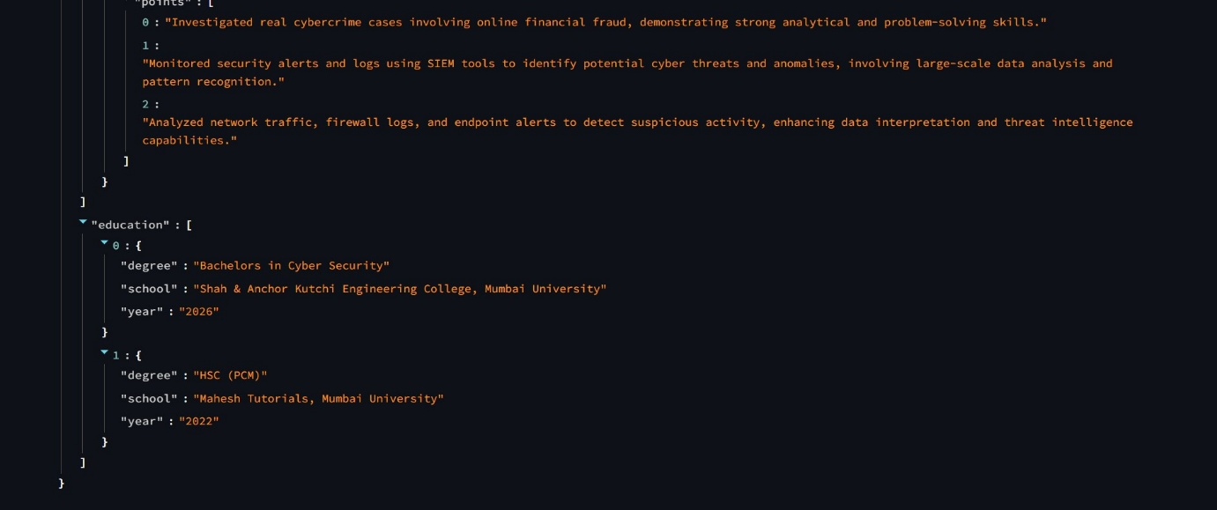

Step 4: Multi-Format Export Engine
The system offers three distinct export pipelines to suit different industry standards:
- Direct PDF Generation:
  - Technology: Uses FPDF to draw a clean, standardized resume layout pixel-by-pixel.
  - Use Case: Quick applications where a locked format is required.
- Word Document (.docx):
  - Technology: Uses python-docx.
  - Use Case: Users who wish to make further manual edits to the AI-generated content.
- LaTeX Source Code (.tex):
  - Technology: String template injection.
  - Templates: Includes "Classic," "Modern," and "Technical" styles.
  - Use Case: Academic, Research, or Engineering roles requiring high-typesetting quality (e.g., via Overleaf).
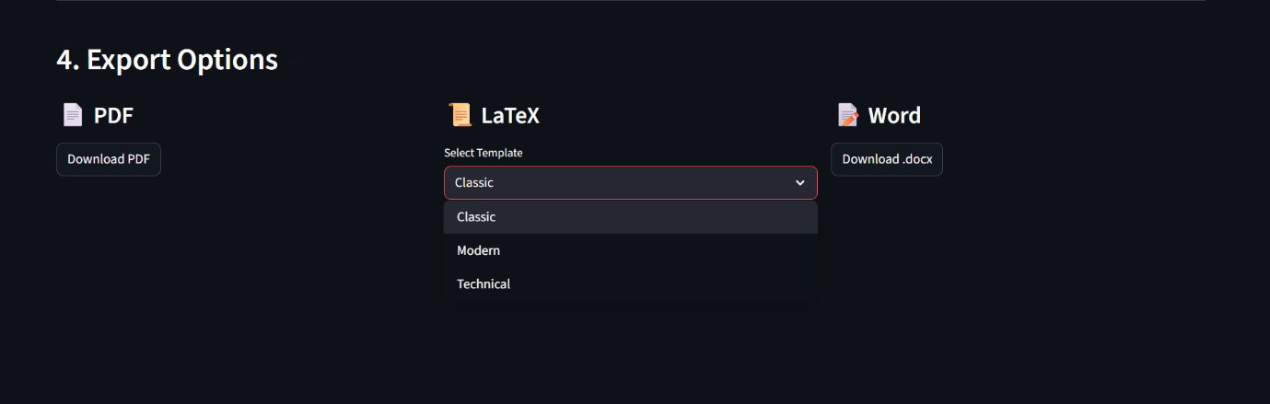
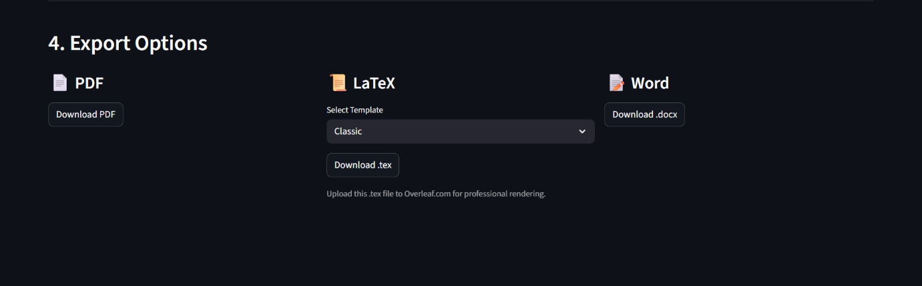
Screenshot of Download options.

